Serverless Media distribution POC  
  
  
Problem Statement:  
 A media company needs to distribute their content (videos, images, documents) in various formats and sizes across different platforms and devices.

**Setup:**

1.Pull the Frontend repository and backend repository into the local

2.Open the Frontend repository and run the following command  
 - npm install

3.Paste the .env file in the root of the frontend repository.

4.After installation is done run the following command

- npm start

1.Pull the Backend repository into the local

2.Setup is already done so no need to deploy the application

**Usage:**

**Uploading File**

1.Go to <http://localhost:3000/> the frontend will authorize and redirect to <http://localhost:3000/upload>

2.Click on the chose file button

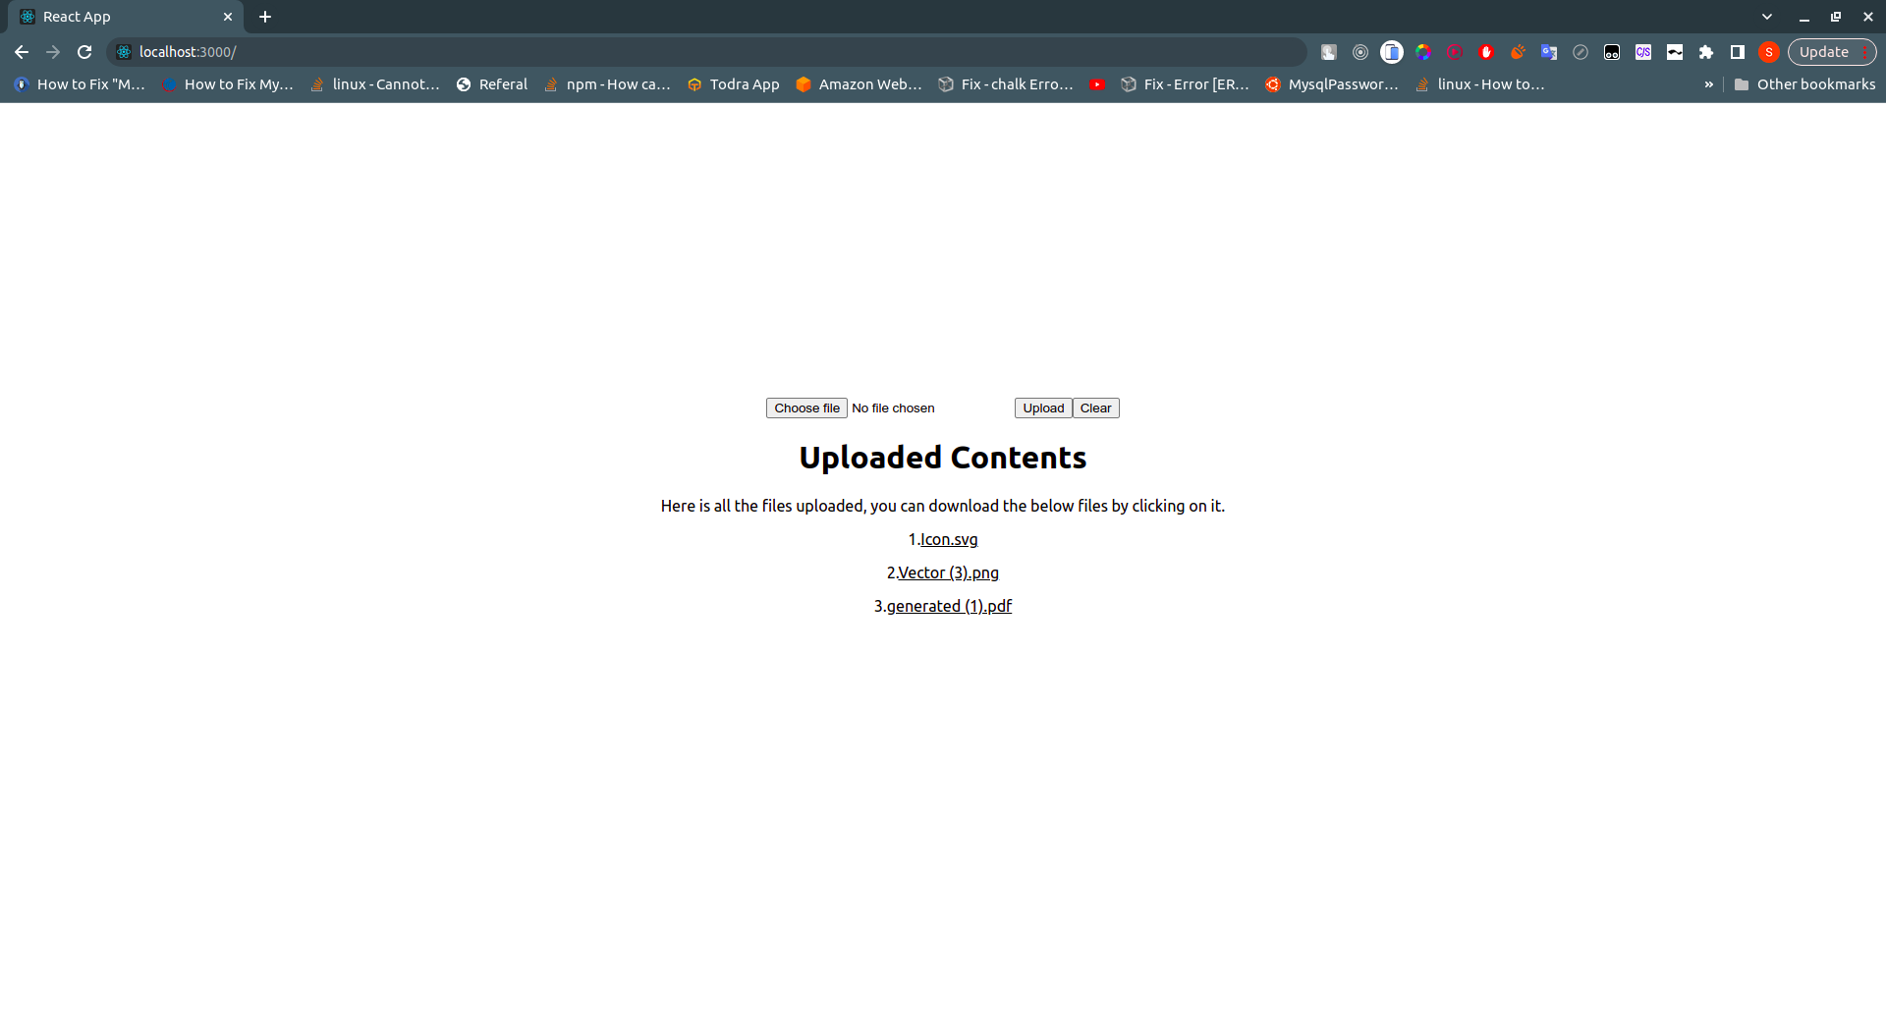

3.Select the file from the file dialog box and click on the upload button

4.After clicking on upload button you will see a loading icon wait till the loading icon disappears.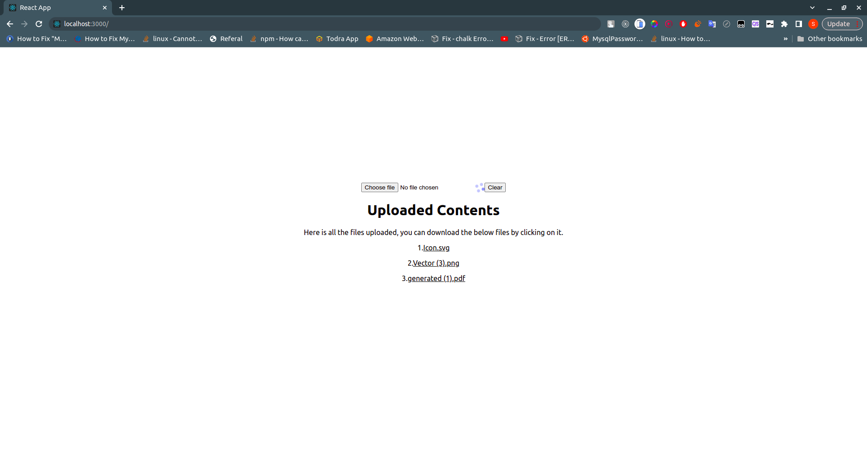

5.After the loader disappears you will see the file name you uploaded in the uploaded contents

**Downloading File:**

1.You can download the file by clicking on the file names under the uploaded contents.

2.